Mr Tom Goldsmith
Clerk of the House
House of Commons
London
SW1A 0AA

11 November 2025
Dear Tom,
Motion on Legislative Consent: Border Security, Asylum and Immigration Bill - UK Legislation
Further to my letter of 26 June 2025, I am writing to notify you that, on 11 November 2025, the Scottish Parliament agreed to a further Motion on Legislative Consent (S6M- 19614) on the Border Security, Asylum and Immigration Bill, which is currently under consideration at Westminster.
I attach the associated Memorandum and extract of the Minutes of Proceedings.
https://www.parliament.scot/-/media/files/legislation/bills/lcms/border-security-asylum-and-immigration-bill/splcms654a.pdf

Yours sincerely,
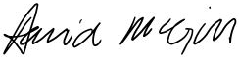
David McGill
Clerk/Chief Executive

EXTRACT OF MINUTES OF PROCEEDINGS—

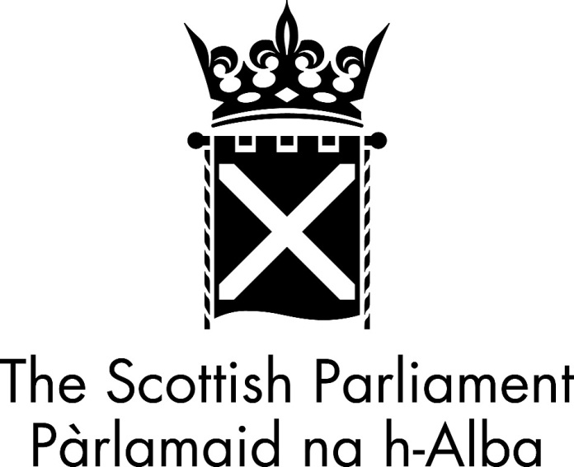

MINUTES OF PROCEEDINGS

Parliamentary Year 5, No. 46, Session 6

Meeting of the Parliament

Tuesday 11 November 2025

Note: (DT) signifies a decision taken at Decision Time.

The meeting opened at 2.00 pm.

7. Border Security, Asylum and Immigration Bill - UK Legislation: The Cabinet Secretary for Justice and Home Affairs (Angela Constance) moved S6M-19614—That the Parliament agrees that the relevant provisions of the Border Security, Asylum and Immigration Bill, introduced in the House of Commons on 30 January 2025, and subsequently amended, relating to clause 53(6) on the breach of interim Serious Crime Prevention Orders (iSCPO), so far as these matters fall within the legislative competence of the Scottish Parliament, should be considered by the UK Parliament.

The motion was agreed to ((DT) by division: For 84 (including 4 proxy votes), Against 1, Abstentions 23).

The meeting closed at 6.19pm

David McGill
Clerk of the Parliament
11 November 2025

